Wireshark: Network Traffic Analysis & IP Investigation
Name: Angel Okeke
Date: 08/14/25

Introduction

The purpose of this lab was to capture and analyze real network traffic from my home network using Wireshark. Instead of using a pre-made file from the internet, I recorded my own traffic inside a Pop! OS virtual machine to ensure a safe and realistic learning environment. The goal was to practice identifying DNS requests, HTTP traffic, and encrypted TLS sessions, as well as researching IP addresses to determine whether they were legitimate or potentially suspicious.

This exercise helped me build skills in packet capture, filtering network protocols, and using WHOIS/IP lookup tools to verify traffic sources core abilities for network analysis and cybersecurity work.

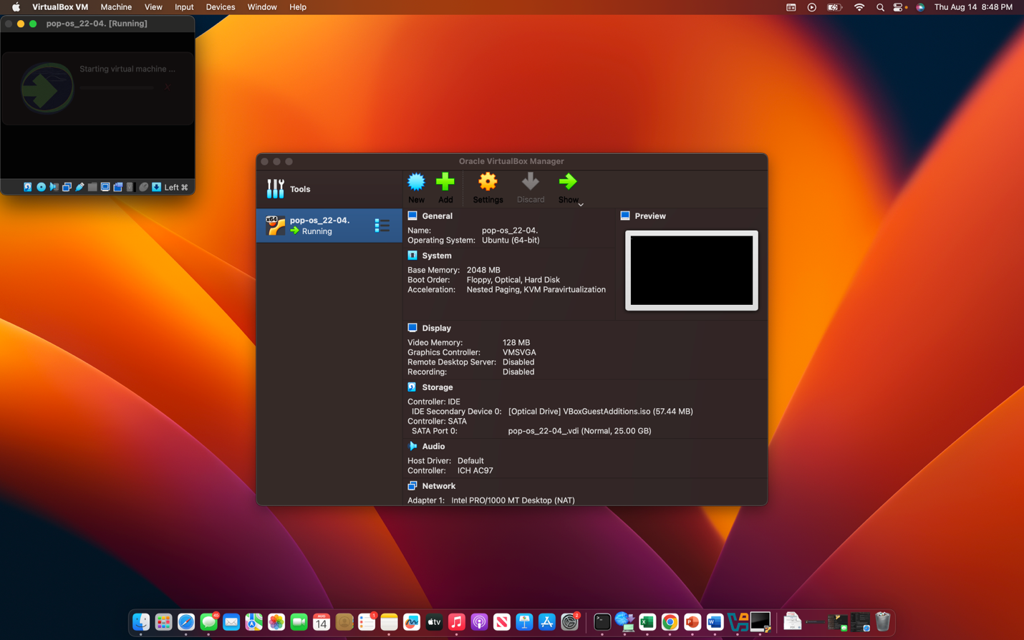
For this lab, I chose to capture and analyze traffic from my own home Wi-Fi network. To ensure a safe testing environment and prevent any unintended changes to my host system, I performed the lab inside a Pop! OS virtual machine running in Oracle VirtualBox.
I began by starting the Pop! OS VM and updating the system’s package lists and installed software using the following command
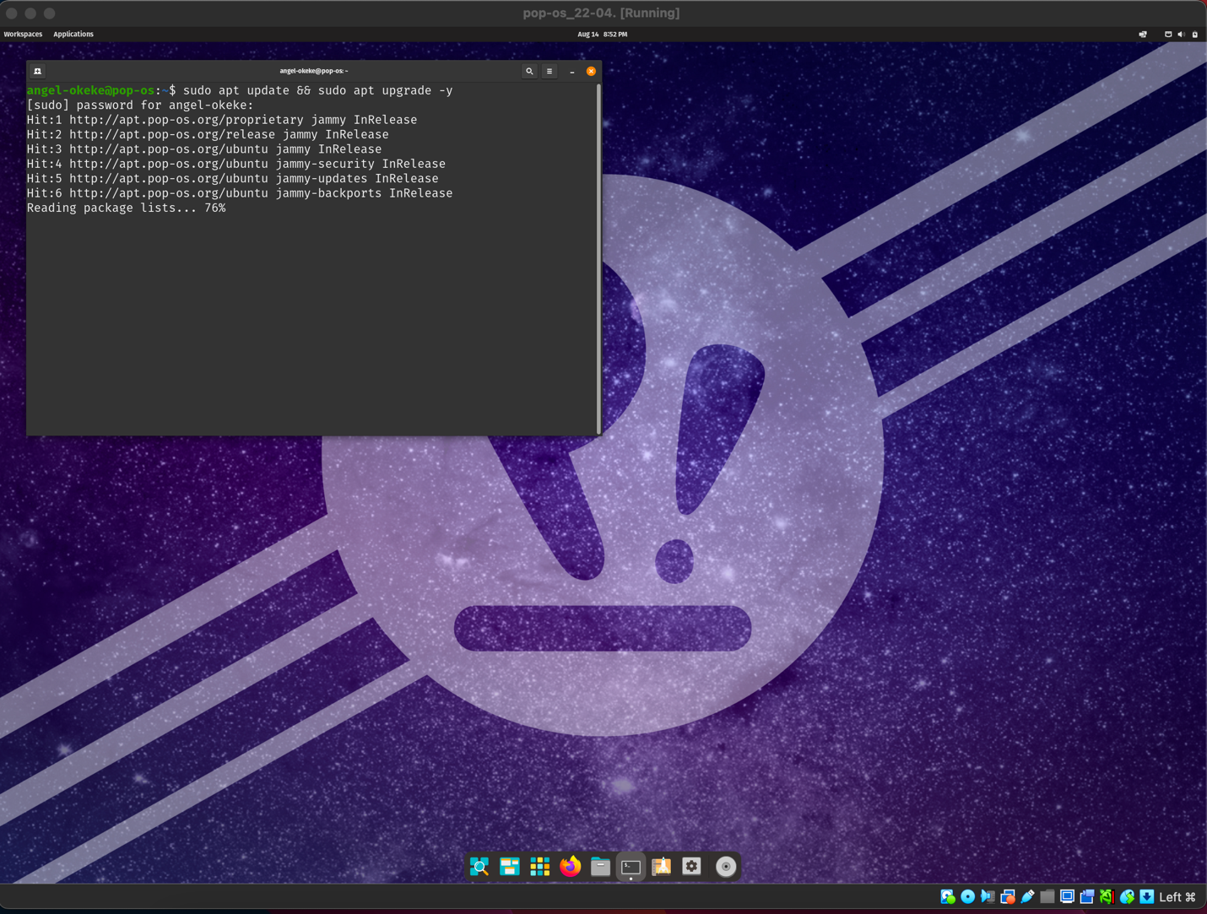
This ensured that the operating system was fully patched and running the latest security updates.
Next, I installed Wireshark via the terminal. During the installation, I enabled the option for non-root users to capture packets. This setting allows me to run Wireshark without elevated privileges, which is considered a safer practice. I then added my user account to the Wireshark group with the command
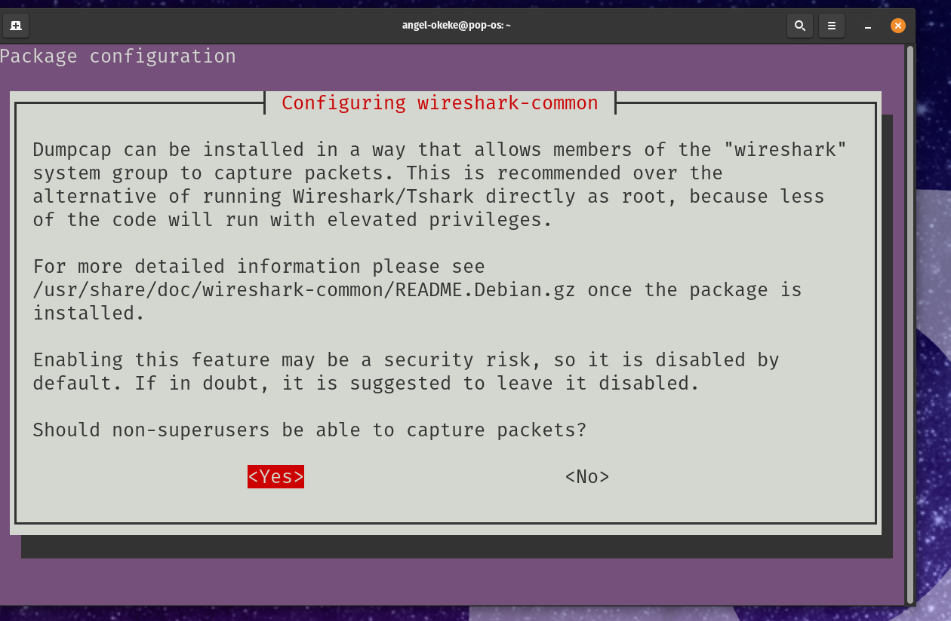
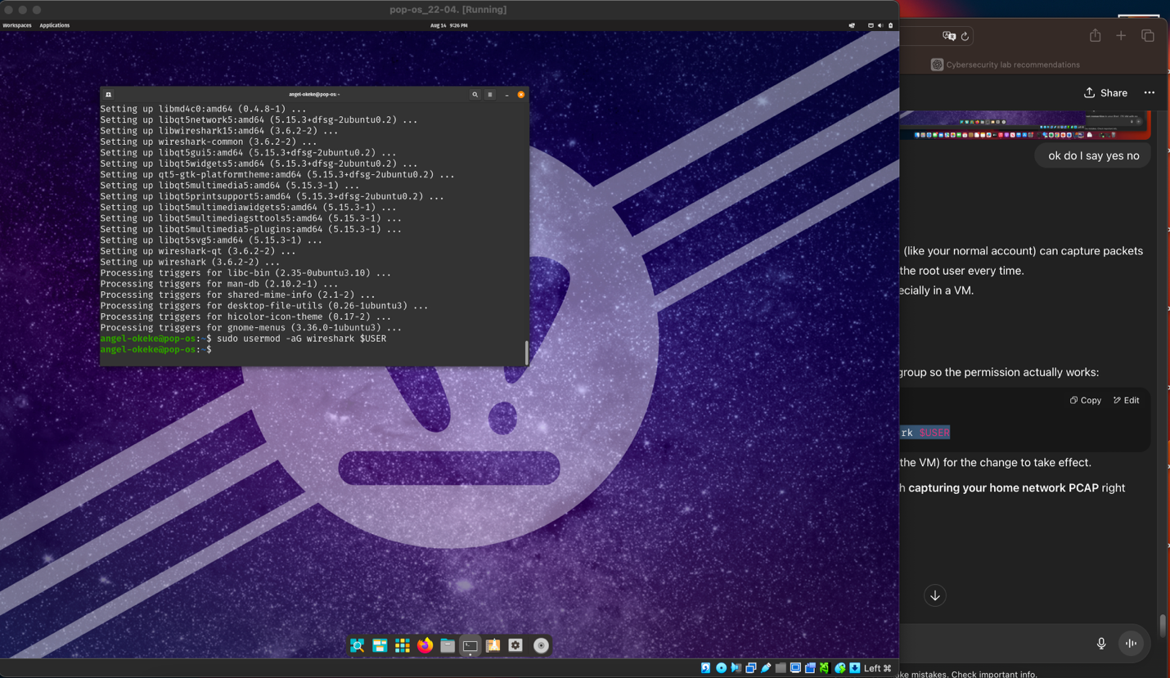
This granted my user account the necessary permissions to perform packet captures without requiring Sudo each time.
After completing these steps, the VM was ready for the traffic capture phase of the lab. Running the lab in a virtualized environment not only improved safety but also kept my capture session isolated from the rest of my network activity on the host machine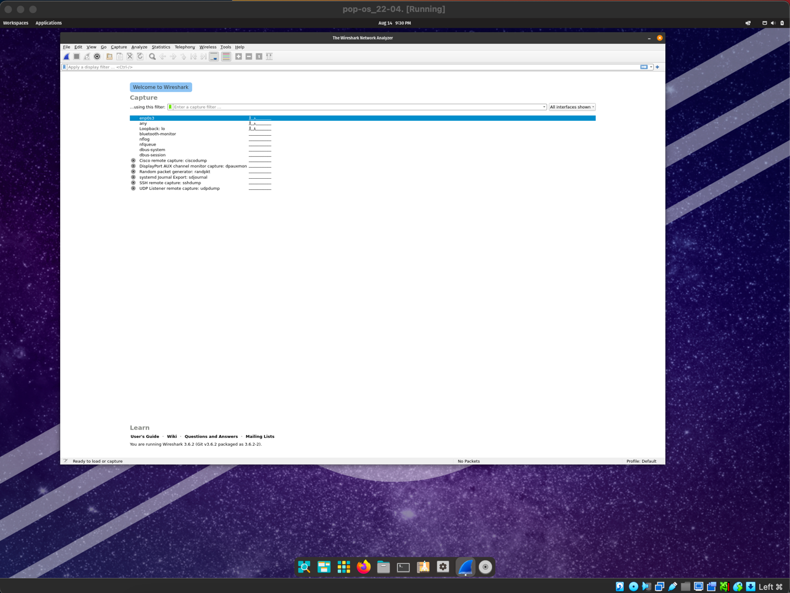
Once Wireshark was installed and configured, I began the capture process by selecting the enp0s3 network interface. This interface was associated with my virtual machine’s connection to my home network. By capturing traffic from enp0s3, I was able to record real-world packets being transmitted between my system and various online services.
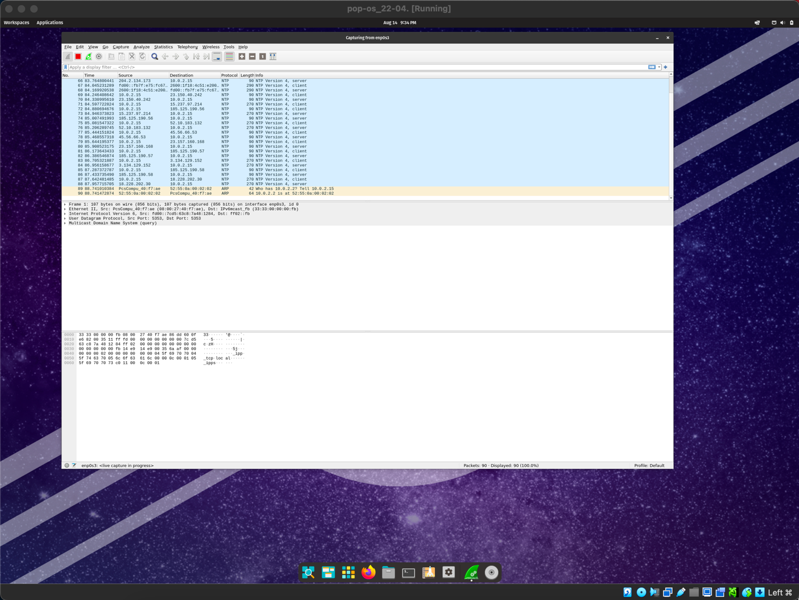 During the live capture, I observed multiple protocols in real time, including NTP (Network Time Protocol) and DNS (Domain Name System) queries. The packet list displayed detailed information such as source and destination IP addresses, protocol type, and packet length. This provided an immediate view into the normal background activity of my network.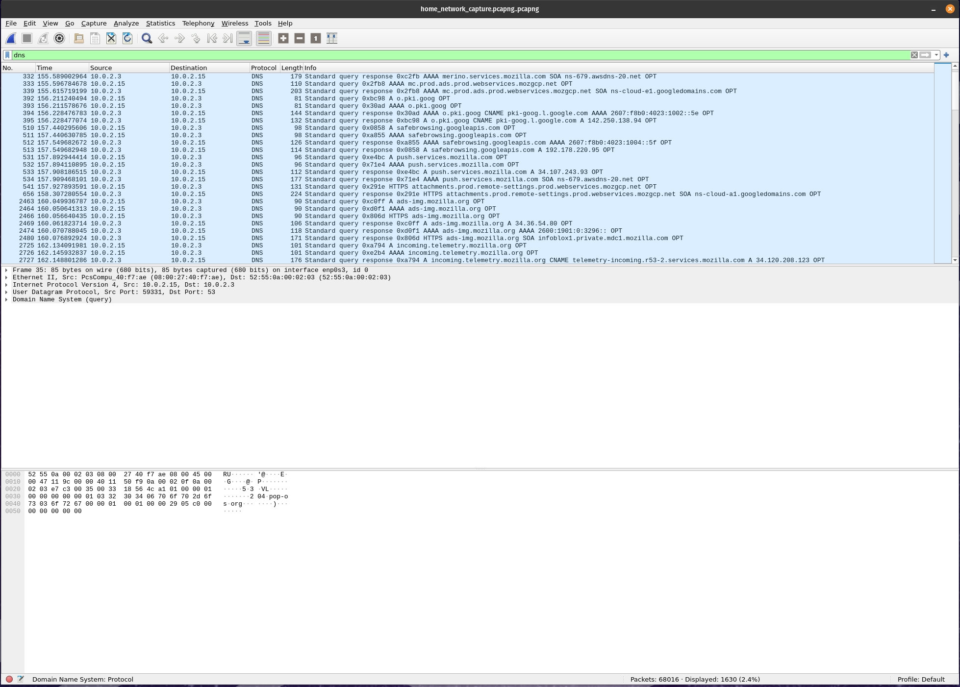 After allowing the capture to run for several minutes, I stopped the recording and saved the results into a. pcapng file for further analysis. From there, I began applying display filters to focus on specific types of network traffic. The first filter applied was DNS, which revealed a list of domain name lookups performed during the session. This included queries to legitimate services such as Mozilla and Google, confirming the presence of normal browser and application activity.
By narrowing the view to DNS traffic, I could more easily spot unusual or unfamiliar domains, which is a common method for identifying potential malicious activity. This filtering process demonstrated how packet captures can be distilled into targeted datasets, making them far more manageable and easier to investigate.
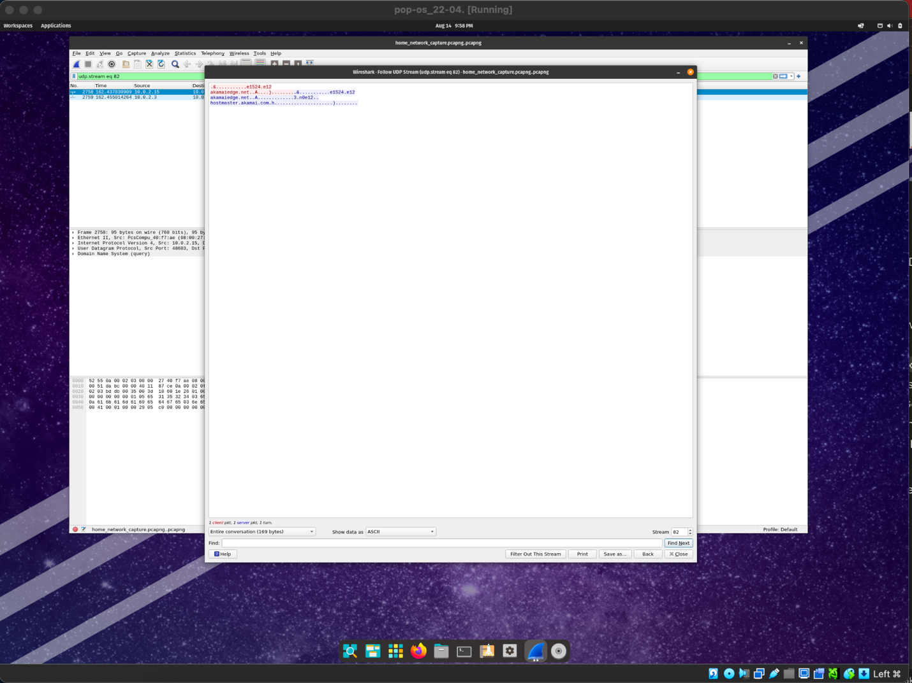 After identifying normal DNS activity, I shifted my focus to searching for suspicious behavior within the packet capture. Using my own judgment, I visually inspected the traffic for unusual domains, random character strings, or unfamiliar hostnames. When I encountered a domain of interest, I followed the packet stream to view the full communication exchange.
In the Wireshark “Follow UDP Stream” view, the red text represents the client-side request being sent from my system, while the blue text represents the server’s response. This color-coded display helped me distinguish between outgoing and incoming data during the interaction. In this case, the communication was with a content delivery network (Akamai), a legitimate and widely used service. Based on the data and the domain reputation, I determined there was no indication of malicious activity.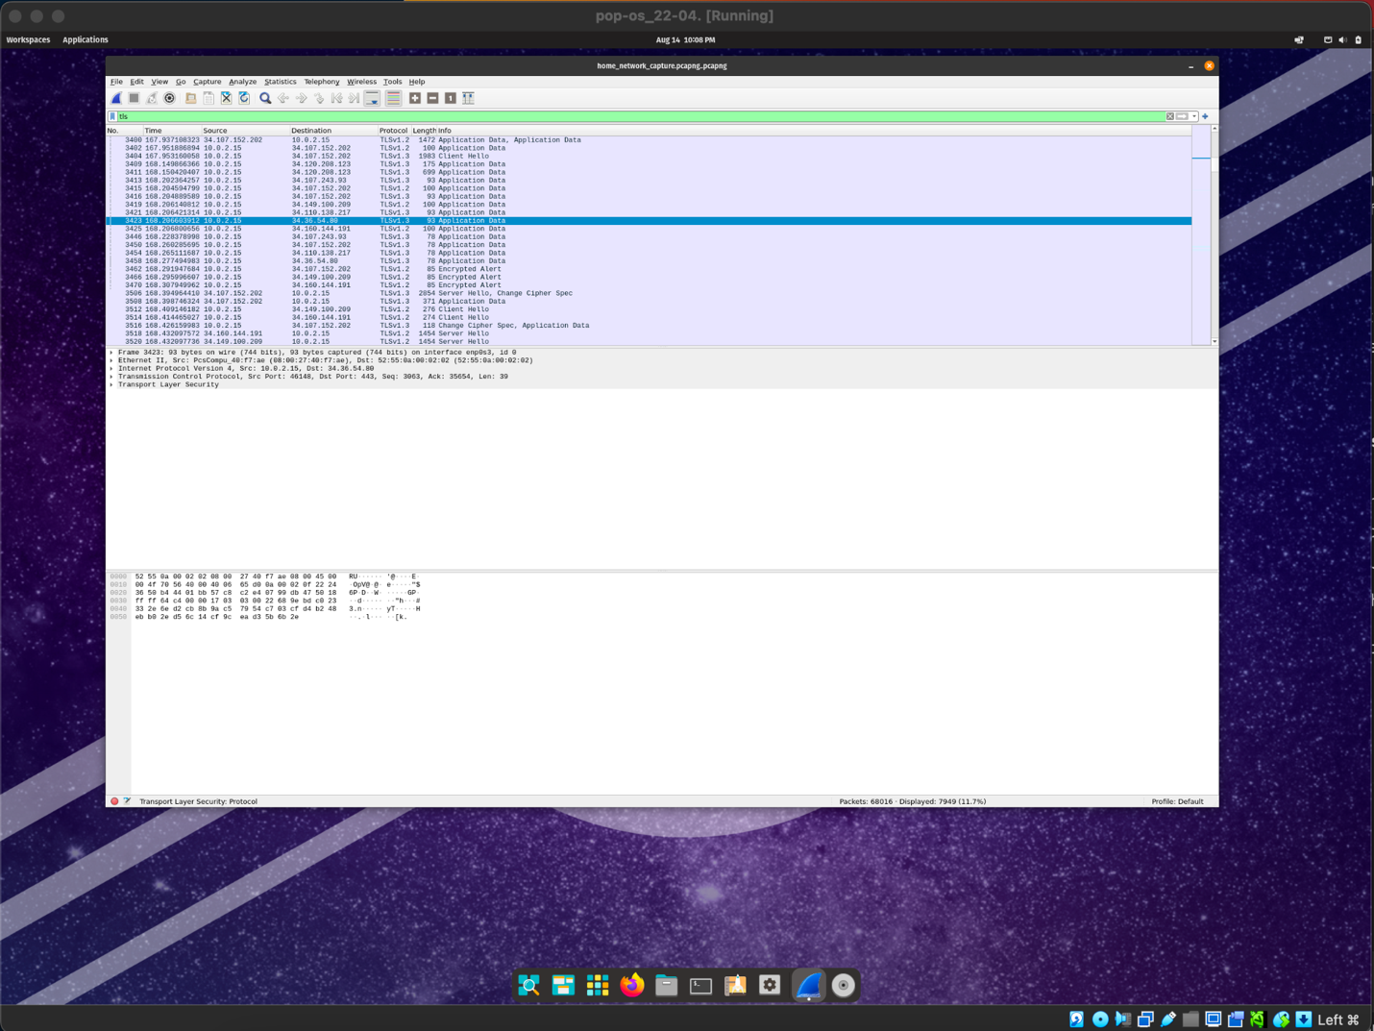 Next, I applied the TLS filter to examine encrypted HTTPS traffic. Although the payload contents are not visible in TLS traffic due to encryption, the packet metadata such as IP addresses and session handshakes can still reveal suspicious patterns. Upon review, the TLS connections were all directed toward well-known services and showed no anomalies in frequency or destination, reinforcing that the activity appeared normal.
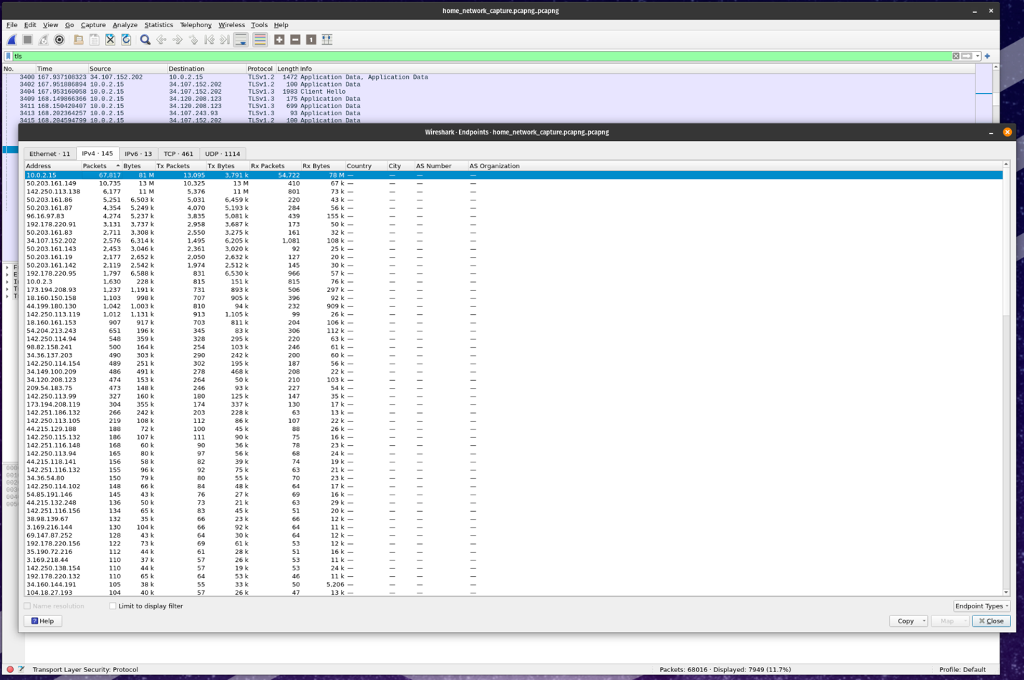
To further validate these findings, I used Wireshark’s Statistics - Endpoints feature. By reviewing the IPv4 tab, I was able to sort endpoints by packet count and identify the IP addresses responsible for the most communication during the capture session. The highest traffic IPs corresponded to private network addresses (used by my VM) and to legitimate service providers, such as Comcast. This confirmed that the most active endpoints were expected and did not pose a security concern.
Through this multi-step analysis visual inspection, filtered protocol review, and endpoint statistics I was able to confidently conclude that the captured traffic represented normal, safe network activity.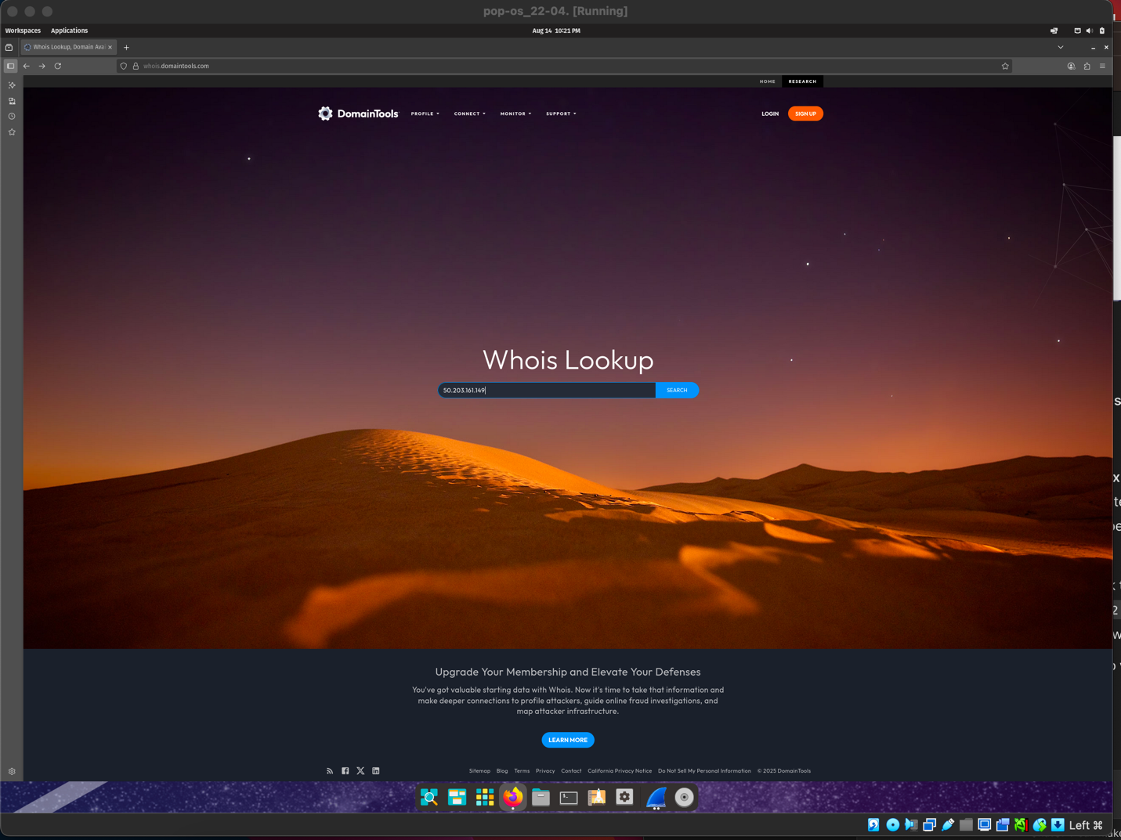 After reviewing the list of IP addresses in the Wireshark “Endpoints” statistics view, I identified the IP generating the highest number of packet requests. I excluded the address beginning with 10. because it is part of a private IP range reserved for internal networks, in this case belonging to my virtual machine.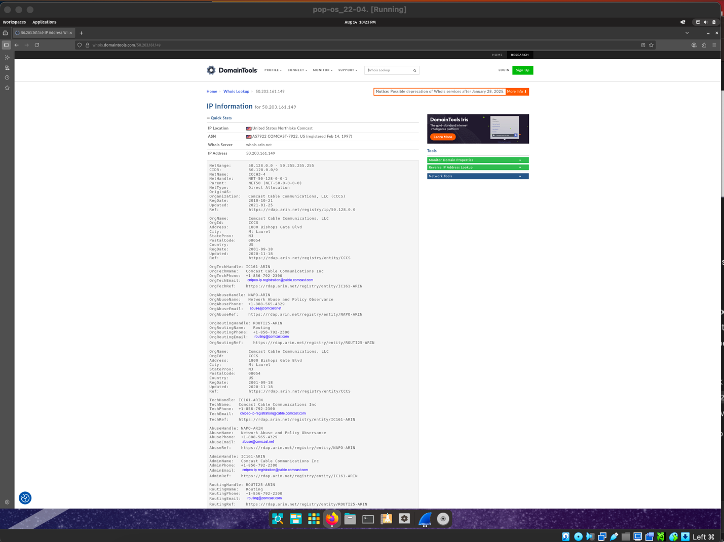 Instead, I focused on the public IP beginning with 50. To investigate further, I performed a WHOIS lookup on this IP address using DomainTools. The results confirmed that the IP belongs to Comcast Cable Communications, our internet service provider. Since this IP was the second highest in packet requests and is associated with a trusted, known provider, I determined that there was no indication of suspicious activity.

Conclusion

In conclusion, the results of this lab show that the network traffic captured during the analysis contained no evidence of suspicious or malicious activity. By carefully inspecting packet data, reviewing both unencrypted and encrypted communications, and verifying high-traffic endpoints, I was able to confirm that the patterns observed were consistent with normal network behavior. The DNS queries and TLS sessions examined followed expected protocols without irregular payloads or unusual destinations.
The endpoint analysis further supported this conclusion. While the most active IP belonged to my virtual machine, the second-highest packet count came from an IP registered to Comcast Cable Communications our internet service provider verified through an external WHOIS lookup. This finding reinforced that the traffic volume was not only explainable but also expected given the nature of the network.
Ultimately, the combination of Wireshark’s built-in analysis tools and independent IP verification proved effective in validating the safety of the network environment. This reinforces the value of a layered investigative approach: not relying solely on packet inspection but also confirming endpoint legitimacy and understanding traffic context. Through this process, I am confident that the network captured in this lab was operating securely and without compromise.

References

“ChatGPT,” Chatgpt.com, 2025. https://chatgpt.com/c/689e8e73-fc3c-8332-9d50-

0caec758593d (accessed Aug. 15, 2025).

“Whois Lookup, Domain Availability & IP Search - DomainTools,”
whois.domaintools.com. https://whois.domaintools.com
Wireshark, “Wireshark · Go Deep.,” Wireshark.org, 2017.
https://www.wireshark.org

